City University of Hong Kong

2022-2023 Semester A

Title:

Optimizing Unmanned Hotels Using Gesture Recognition

Project Plan Report

Supervisor: Dr WONG, Hau San Raymond

Name: Fung King Shun

Student ID:56659723

Contents

1. Motivation & background information 3

1.1. Background 3

1.2. Current Development Problem 3

2. Problem statement, project objectives & scope 4

2.1. Solution 4

2.2. Project Goals 4

2.3. Project Scope 5

3. Technical Consider 8

3.1. Hand Tracking Library 8

3.2. Database Design 8

3.3. Number of Hand Tracking 9

3.4. Website Browser 9

3.5. Payment Gateway 9

4. Non-Technical Consider 10

4.1. Role of Users 10

4.2. Real World Operating Environment 10

5. Major technical components 12

5.1. Server Architectures 12

5.2. Coding 13

5.3. Algorithm Design 14

6. Description of Each Component 15

6.1. AI Section 15

6.2. Website Section 15

7. Expected results & deliverables 17

7.1. Project Result 17

7.2. Deliverables 18

8. Project schedule 19

8.1. Timetable 19

8.2. Gantt Chart 20

# Motivation & background information

## Background

Under the covid-19 epidemic, people's lives have begun to change to varying degrees. Among them, the root cause of the worsening of the epidemic is human-to-human contact. Another reason for the accelerated development of the virus around the world is the cross-infection between countries.

Especially in Hong Kong, as an international society. Every day, different tourists or workers enter Hong Kong. According to the immigration statistics of the Hong Kong Immigration Department, in the past 2021-2022, there were about 90,000 visitor arrivals to Hong Kong. In order to prevent the spread of coronavirus. So, the Hong Kong government has also implemented some regulations, such as compulsory quarantine in hotels for people returning to Hong Kong from high-risk areas (quarantine hotel regulations). However, there is still a certain chance of being infected for waiters working in hotels.

Therefore, some countries have begun to develop unmanned hotels to solve this problem by replacing waiters with robots.

## Current Development Problem

Although the application of unmanned hotels can reduce the chance of infection. But for the occupants still need to use the public machines in the lobby to complete the check-in / check-out procedure before entering the room / leaving the room. Owing to these public machines are operated in traditional ways, such as touch screen or button control. Therefore, another problem is that occupants can become infected by touching these public machines.

# Problem statement, project objectives & scope

## Solution

The human-machine interface is developing in a non-contact direction, among which speech recognition and gesture recognition are the current key development technologies, especially gesture recognition does not require touching the device, nor does it make sounds to interfere with the surrounding environment and is gradually accepted by users.

So, gesture recognition is a suitable solution to improve the control of public machines in unmanned hotels. Also, I will extend the project to using gesture authentication. Registrants will need to customize their own gesture authentication when running the check-in process using a public machine. After accomplished the check-in process, occupants can use their own customized gesture authentication to unlock the hotel room door.

In addition, it should have a website to provide a complete online booking system which connected the database. To solve the problems related to reservations, effectively improve the previous operation mode, and greatly improve work efficiency.

## Project Goals

This project aims to optimize the operation process of the current unmanned hotel using gesture recognition. Try to find another innovative technology, not only to replace the current traditional method to control the public machines, but also to achieve gesture authentication to solve the traditional problem of needing to touch the door handle or use keycard to open the door. Using detect your hand or finger in a specific way in front of the webcam to tell the machine what action needs to be done and user identity verification.

## Project Scope

First, there are two kinds of occupants to use the unmanned hotel services, namely walk-in and online booking.

For online booking, an unmanned hotel website will be established, through which occupants can search for information, reserve hotel rooms in advance, enroll an account, login account or logout account. Then the occupant will receive the QR code by enrolled email. Next, occupant needs to enter the unmanned hotel at the appointed time and use the public machine to scan QR code complete the check-in process. But this time the public machine uses gesture recognition (using computer simulation) to complete the transaction. And uses gesture authentication to customized identity gesture to unlock the room door. Finally, the check-out of the occupants is also done using a public machine with gesture recognition.

The second type of occupant is walk-in, these guests can go directly to the unmanned hotel to complete their check-in using a public machine with gesture recognition. But this time walk-in user needs to enter extra information and more steps than online booking users when they are using public machines. Because for online booking they will receive a QR code that is scanned by public machines and pre-entered with information.

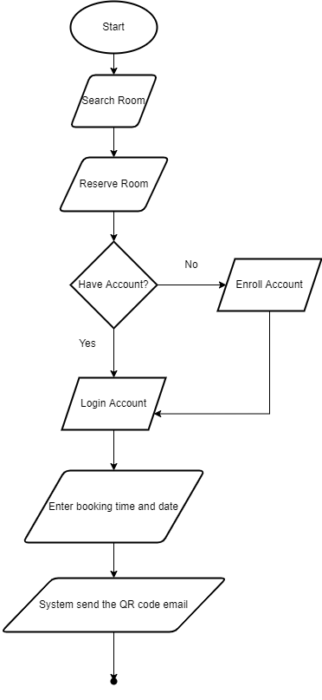

Simple flow chart of online booking system

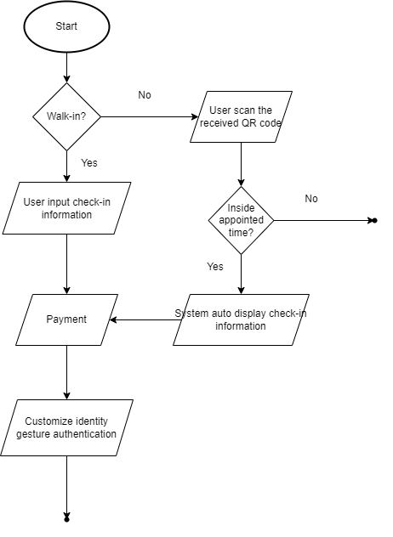

Simple flow chart of public machine

# Technical Consider

## Hand Tracking Library

Due to the hand tracking is a very ripe technology nowadays, so the project will use one of the open-source libraries called “cvzone” to assist gesture recognition and gesture authentication implementation.

Step 1: Using API function “findHands” to keep track of hand computations and detect hand motion and orientation from input image.

Step 2: Using API function “fingersUp” to find how many fingers are up and each of the fingers up or down will denote as new action.

Step 3: Base on each actions design a new algorithm to calculate the finger x, y coordinate how to control the UI and Authenticate.

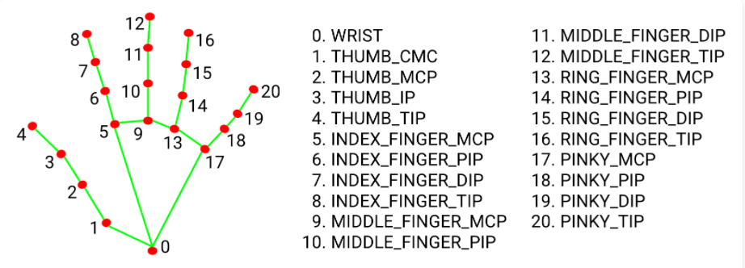

Key points of Hand Landmark Model

## Database Design

Another important thing is how the data is stored. Since the data will be shared to websites and public machines in both regions, the data must be accurate, consistent and reliable. If a poorly designed database might make it more difficult to access the information or jeopardize the accuracy of data. It is recommended to use a relational database because our database data record tables and tables should be relational. Such as a hotel room remains by a hotel guest, they have a one-to-one relationship.

## Number of Hand Tracking

Hand tracking will set the maximum number of hand detections to one hand. Because whether controlling the UI or customizing own authentication pattern, if applying one hand solving method, it can provide a more stable performance.

## Website Browser

For website development, deployment will be based on "Google Chrome". So, it ensures that the source code can run it. But it is not recommended to run on other browsers.

## Payment Gateway

When the user progresses to one of the processes in the public machines which is payment. It will only simulate the input process of payment and will not actually connect to the real payment gateway for transactions.

# Non-Technical Consider

## Role of Users

In this project, it is assumed that there are only two roles (walk-in and online booking) to use the system. The project will not consider the function that other users will use. For example, there will be a “super user” or “manager” who has the permission to manage the data of database. The target users will focus on people who use unmanned hotels.

## Real World Operating Environment

Since the method of gesture recognition is to use a webcam, it is different from gesture recognition using wearable devices. The requirements for the real-world environment are even greeters. The following are the assumed operating conditions:

* Illumination Conditions

The effects of illumination are drastic on the pixel image. Hand exhibit different shape under different illumination conditions.

Solution: Assume running in a well-lit environment.

* Cluttered or Textured Background

The “Hand Landmark Model” accuracy rate will decrease according to complex background. Background noise may be incorrectly assessed as hand.

Solution: Assume running in a clear background.

* Webcam Resolution

Resolution is a key parameter determining the capabilities of a machine vision system. High resolution can ensure image quality and improve the success rate.

Solution: Assume webcam has at least 720p/1080p.

* Capabilities of Computer

Running an artificial intelligence program requires a lot of computer computation. Also, the project will use the same computer to run as the web server and database server. Therefore, there are certain requirements for computer hardware.

Solution: Assume running at advanced computer height CPU, GPU and Memory.

# Major technical components

## Server Architectures

The following is the server architecture required by the system:

|  |  |
| --- | --- |
| Database Server | MY SQL |
| Web Server | Apache |

I choose MY SQL + Apache as a combination. This is because I need a web server to provide information browsing services for unmanned hotels on the internet, which will run PHP code. Also, I need a database to store data such as hotel room information, account information, etc. Therefore, the MY SQL + Apache combination is the easiest to install because they are free and already have a collection of installation packages, namely XAMPP. In my case, I'm using only one computer running as a database server, web server and gesture recognition system for python code, so XMPP can support these architectures.

Architecture diagram of server

## Coding

For the software part, I need to use different programming languages ​​to implement website and system. The following is the main software composition for coding:

* Main Programming Languages
* Python

Python is an interpreted, high-level, and general-purpose programming language. So, it used to develop an AI part application in my project which is gesture recognition and gesture authentication.

* PHP

PHP will be suitable for web development and used in embedded HTML and CSS. PHP will be mainly responsible for developing dynamic pages. The dynamic web page will be a UI to interact with the user.

* Main Library or API
* OpenCV

As the project is related to the field of computer vision. To develop real-time image processing, computer vision. For example: convert every second frames into images and then process them. So OpenCV is a qualified library.

* CVZone

CVZone is a computer vision package it can be easy to run image processing and call the AI functions. Also, the core of CVZone it uses the OpenCV and Mediapipe libraries. Don't have to worry about compatibility issues. Also, I will use CVZone API to handle gesture recognition and gesture authentication.

* Database Management
* SQL

Because I would use a relational database structure. SQL will be used to manage data processing in relational database management systems. Contains data insert, query, update and delete etc.

* Environment
* IDE:

|  |  |
| --- | --- |
| Website | Brackets |
| Gesture Recognition and Gesture Authentication | PyCharm |

The above is the IDE that will be used for program development, testing, or debugging.

## Algorithm Design

Although the AI ​​model of CVZone has been used for hand tracking to extract the skeleton and key points of the hand. But in fact, I still need two powerful algorithms to help me to complete the work of gesture recognition and gesture authentication respectively. This part will be the key to the success of the project.

In addition, design a new algorithm to solve the problem will also be the main learning process of my FYP. Project the real problem to the mathematical problem, and then calculate the mathematical problem through the algorithm and output it to the correct answer.

# Description of Each Component

Actually, the whole FYP system have two big component they are AI part and Website part. And base on each big component should have many small components which is the functions.

## AI Section

* Gesture Recognition Algorithm

I will use python code to create a display screen of input UI for user to use. Next, write an algorithm that calculates the x, y coordinates to control the mouse movement and keyboard input. Checking the user is it has triggered any input conditions. If yes, algorithm will react accordingly. So that user can use gesture to complete various computer operations.

* Gesture Authentication Algorithm

First, it is to find a way to extract the user input into a gesture action with a time factor. Then use the algorithm to calculate whether the customized gesture action is how similar and how many like the gesture action of current input data.

## Website Section

* Register Function

To confirm the identity of the user of booking the hotel rooms on the website. They need to sign up for an account first.

* Login Function

Concerning security and record booking information data into database. Users need to enter their register account email and password to log in before using booking function.

* Logout Function

The logout function is suitable for users who have logged in to the website and ended using the website.

* Booking Function

The user can use the online booking method to complete the reservation in advance. Simplify the process and operation time to use public machines in the hotel.

* Search Information Function

A search function will be provided for users to more quickly find hotel rooms which they are looking for.

* Sending Email Message Function

In order to facilitate and simplify online booking users to operate public machines. So, when the user completes the appointment by online website, they will receive a message containing a QR code to send to them. As long as they enter the hotel within the reservation time and scan the QR code with the public machine, the public machine will automatically enter the pre-data which is the information that has been entered on the website.

# Expected results & deliverables

## Project Result

An ideal FYP should be able to completely simulate the operation process of optimized unmanned hotels. From the beginning of the user's reservation on the website to the end of the public machine to complete the check-in and authentication to open the door, the entire operation process should have the correct output.

* Website

A website has completely successfully simulated an online booking hotel room process. After the user enters the booking data through the website, the system will store the correct data in the database.

* Gesture Recognition

Users can operate the computer using different gesture actions. Contains the direction of moving the mouse and the click action. In addition, text words A-Z for English and 0-9 for numbers can be entered using gestures.

* Gesture Authentication

Users can create their own independent gestures during the check-in process. Then, the user will simulate and successfully open the hotel room with their own defined gestures.

## Deliverables

* Virtual Mouse

It provides an infrastructure between the user and the computer using only a camera with finger x, y coordinate. It allows users to interface with machines without the use of real mouse. Also, user can use different gesture recognition action control mouse functionalities.

* Virtual Keyboard

It provides a virtual user interface for the keyboard. The user can enter text or numbers using the finger x, y coordinates. And the correct result will be displayed on the computer.

* Gesture Authentication

Collect the data entered by the user on the public machine, and then compare whether the data pattern entered by the user is the same. Automatically check whether the result passes.

* Online Booking Website

The website will display the rooms and room details that are now available. Users can book rooms in advance.

# Project schedule

## Timetable

|  |  |
| --- | --- |
| Stage | Schedule |
| Project Plan | 1-Sep-2022 to 20-Sep-2022 |
| Prototype1 implementation  (Database Design, Website UI Design) | 21-Sep-2022 to 21-Oct-2021 |
| Interim Report I | 24-Oct-2022 to 11-Nov-2022 |
| Prototype2 implementation  (Python Gesture Recognition and Gesture Authentication) | 14-Nov-2022 to 13-Jan-2023 |
| Interim Report II | 16-Jan-2023 to 10-Feb-2023 |
| Final prototype  (Testing, Debug) | 13-Feb-2023 to 28-Feb-2023 |
| Final Report | 1-Mar-2023 to 31-Mar-2023 |
| Final Report Presentation and Demonstration | 3-April-2023 to 6-April-2023 |

## Gantt Chart

